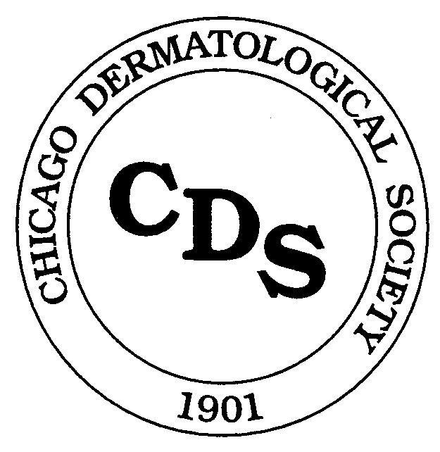
Chicago Dermatological Society
Research Grant Application
Resident Quality Improvement Award

v 04.2021
Grant Cycle: Fall Cycle Spring Cycle
(check one)
Title of Grant Proposal:
Amount Requested: $

Applicant Information
Name (first/last/degree):

Check one: PGY-2 PGY-3 PGY-4
Date of Birth (mm/dd/yyyy):
Current mailing address:

Telephone (Office): (Mobile):
Fax:
E-mail:
Position: Current During project timeframe

Other Sources of Support
List other pending applications or approved funds received from any source for financial support of this program or project, and indicate amounts.
Source: Amount: $
Source: Amount: $
Source: Amount: $

Continued next page

Budget Data
Provide a detailed budget in a separate attachment. Include a concise statement of how you propose to allocate funds (i.e., amount and for what purpose). Separately list each item of equipment with a unit acquisition cost of $500 or more. Itemize supplies such as glassware, chemicals and animals in separate categories. If animals are involved, state how many are used, their unit purchase cost, and their unit care cost. Clinical investigators should submit details of projected costs for laboratory tests, biopsies, medications, and related items. Summarize budget below.

Budget Summary

CDS Grant Funds Matching Funds Total

(if any)
Equipment (non-expendable) $ $ $
Supplies (expandable) $ $ $
Other $ $ $

Total $ $ $

Institutional Information
Name of Institution:
Location (city/state):
Sponsoring Department, Service, Laboratory, or equivalent:
Preceptor of Sponsoring Department:
Address: Telephone:
Head of Sponsoring Department:
Address: Telephone:

Dean or Administrative Official:
Title:
Address: Telephone:

Fiscal Officer (to whom check will be sent):
Title:
Address: Telephone:
Check should be made payable to:

IRB Administrative Official:
IRB Project Number: Approval Status

Signatures

Signature of Applicant Date

Signature of Preceptor Date

Signature of Department Head Date

Signature of Dean or Administrative Official Date

“I certify that the statements in this application are true to the best of my knowledge. In the event that I receive simultaneous funds from other sources (except departmental funds of my sponsoring institution or National Institutes of Health training grants), I understand that my grant will be terminated as of the day I begin to receive such funds. I agree to immediately notify the Chicago Dermatological Society in writing and will return any unused award funds. I hereby agree to provide a written progress report to the Chicago Dermatological Society within 60 days prior to the termination of the grant.

Signature of Applicant Date

NOTE: Applications will not be processed unless all components have been completed and submitted with any required supporting materials by the deadline date .
Applications will not be returned for correction of deficiencies

